Rabba Fine Foods

Social Media and SEO Audit
Prepared by Vynzo Media | 29 October 2026
Rabba has a clear proposition: a neighbourhood grocery store that is always open. The website and social profiles communicate that promise, but several practical details weaken the journey from discovering Rabba to choosing a store. The first priority is to correct conflicting opening-hours markup, repair broken links and improve the pages that answer location and availability searches.
On social media, the available sample shows limited conversation around mostly promotional posts. Instagram and Facebook should connect useful food content to a specific nearby store. LinkedIn can build on community impact and leadership stories. YouTube currently functions more as a corporate archive than a regular discovery channel.

What deserves attention first
Priority | Finding | Recommended response
Immediate | Homepage schema says Tuesday to Sunday 09:00–17:00; visible site says Open 24/7 | Separate the corporate entity from individual stores and verify actual branch hours
Immediate | 13 crawled URLs return 404; homepage links to one of them | Repair current internal links and redirect only to equivalent live pages
High | 170 crawled URLs have no H1; 25 have duplicate descriptions | Fix page templates and write page-specific metadata
Monitor | Supplied mobile audit: 1.56 s load time, 82.00 ms interactivity and 0.00 visual stability; all GREAT | Preserve performance; reconcile the separate lab test before calling speed a weakness
High | Facebook 4 posts / 5 engagements; Instagram 2 / 7 in the available window | Test useful local content and track store-intent actions

Scope and confidence
Social performance covers 16–28 October 2026, inclusive, in America/Toronto time. The Socialinsider subscription allows only a rolling 14-day history, so a 90-day performance conclusion is not supported. The profiles were added on 29 October; historical completeness is not independently guaranteed. The SEO crawl is complete and dated 29 October. Ubersuggest’s latest domain traffic month is September 2026.
Counts are labelled by source throughout. Estimates, live observations and recommendations are kept distinct. No sales attribution, private audience demographics, advertising results or competitor benchmarks are claimed.
Evidence: S1 Ubersuggest crawl; S2 Socialinsider summaries; S3 Ubersuggest PageSpeed; S4 direct website inspection. Full source register appears at the end.

Social performance overview
Channel | Followers 28 Oct | Posts | Engagements | Engagements per post
LinkedIn | 2,455 | 0 | 0 | N/A
Facebook | 13,273 | 4 | 5 | 1.25
Instagram | 3,971 | 2 | 7 | 3.50
X | 648 | 0 | 0 | N/A
YouTube | 18 | 0 | 0 | N/A
These are Socialinsider’s returned records for a 13-day window. Zero posts means no posts returned for the selected profile and dates. It does not establish that a channel has never been used, that all historical posts were captured, or that older videos received no views.

Read the engagement rates carefully
Measure | Facebook | Instagram
Provider average rate excluding zero-valued posts | 0.018835% | 0.088139%
All-post mean of returned per-post rates | 0.009418% | 0.088139%
Posts with zero recorded engagement | 2 of 4 | 0 of 2
Returned formats | 3 photos and 1 album | 1 image and 1 carousel
The Facebook summary omits the two zero-rate posts from its engagement-rate average. The all-post mean above includes them. Use the same definition when comparing periods. Small counts make rankings unstable: one extra comment can materially change the result. There is no basis here for claiming that one format or posting time is a proven winner.

What can and cannot be measured
The tracked profiles are public profile types, rather than owned-authorised profile types. Some payloads contain reach or impressions, but these have not been established as first-party Meta analytics. Facebook also returns fractional daily reach in places and different values across daily and post endpoints. Those fields are excluded from the headline analysis. Null data and unsupported zero fields are not treated as measured performance.
Follower endpoints show small changes between the first and last observation: LinkedIn +2, Facebook −2, Instagram −3 and X +4. These are differences between returned snapshots, not verified acquisition or churn. YouTube’s daily subscriber series fluctuates; its current count of 18 is independently supported by vidIQ and the live channel.
S2: Socialinsider get_posts_summary, get_top_posts and get_profile_data for all five supplied profiles; date start 16 Oct 00:00 EDT, end 28 Oct 23:59:59 EDT. Calculations use returned records only.

Instagram audit
The live profile clearly states the 24-hour grocery proposition. It shows 3,971 followers and 1,419 following, with Brands, Recipes, Inspiration and Community highlights. The first displayed link is rabba.com/promotions with four additional links. This gives the account a useful foundation; the next improvement is to make the route to a store or current offer easier to choose.
Post date | Topic | Likes | Comments | Engagement
21 Oct | Tim Hortons inside 15 Rabba locations | 3 | 1 | 4
27 Oct | Alcohol availability from 7 AM to 11 PM | 3 | 0 | 3
The Tim Hortons post produced one more engagement than the alcohol carousel. With only two posts, this is a content clue to test, not evidence that images outperform carousels. No Reel was returned within this window; the live grid does show an older Reel dated 8 October, so it would be inaccurate to say Rabba never uses Reels.

Content and conversion improvements
Turn “15 locations” into a practical choice: show a named branch, its coffee counter and a link to the Tim Hortons locator. A short store walkthrough or coffee-and-grocery routine can demonstrate the convenience more clearly than another text-led promotional graphic.
Test recipe-led Reels using products available at Rabba, then lead viewers to ingredients and a nearby store. Add a Locations highlight and a clearly dated Offers highlight alongside the existing themes. Review the five bio destinations and place the current flyer and store finder first if those are the intended customer actions.
The 27 October permalink returned an age-restricted login screen during direct inspection. It is therefore included as a Socialinsider-reported post, with its caption and metrics attributed to that source. Restricted visibility may affect what logged-out visitors see; it does not prove a reach penalty. Keep grocery opening hours and alcohol sales hours clearly separate.
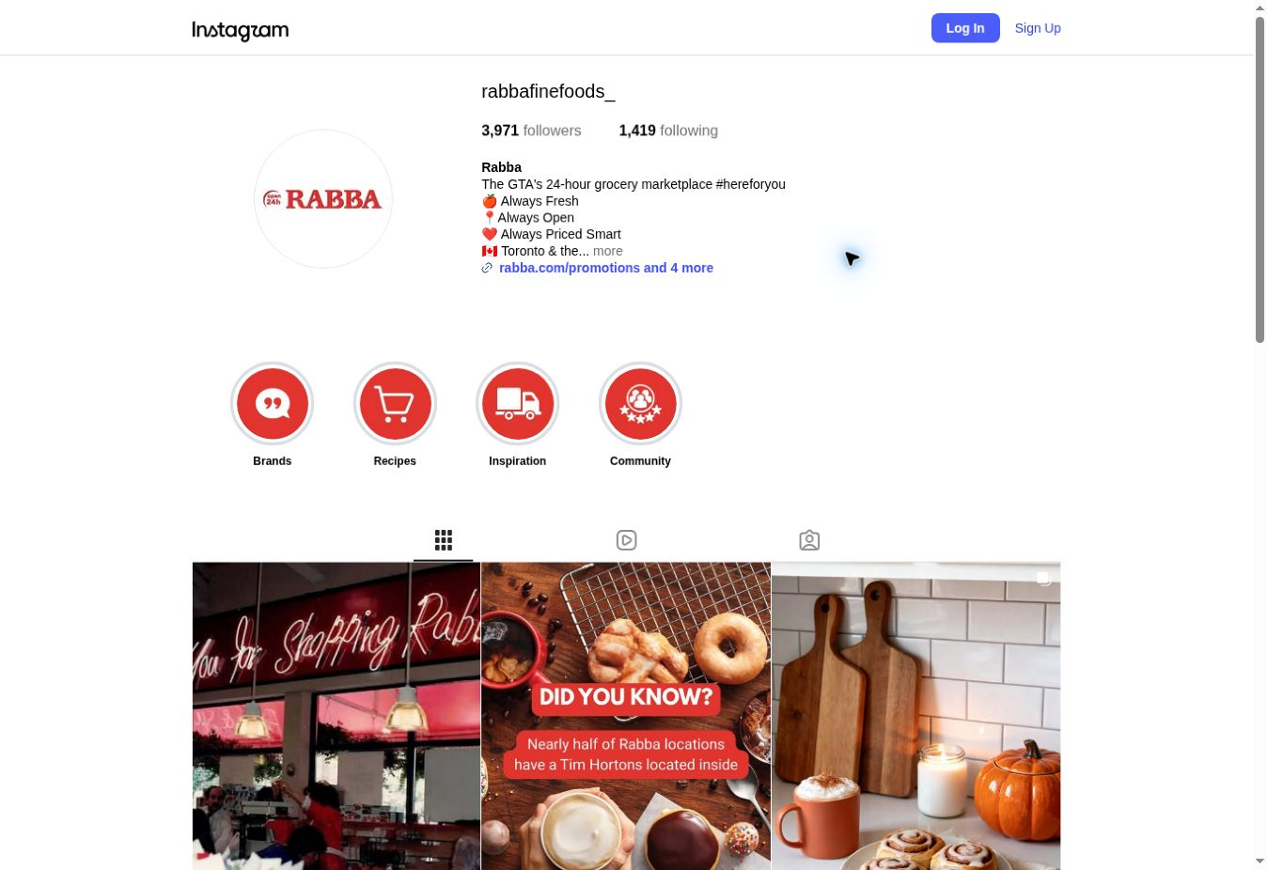
S2 Instagram profile rabbafinefoods_; S5 live Instagram profile 29 Oct and post access check. Permalinks and original returned metrics are in the evidence package.

Facebook audit
Facebook provides practical contact information: the Kennedy Road address, customer-care email, telephone number, website link and an Always open label. The public header shows a rounded 13K followers; Socialinsider’s 28 October count is 13,273. The exact provider count should not be presented as an exact count independently read from Facebook.
Date | Topic | Engagement | Observation
21 Oct | 15 Tim Hortons locations | 3 | 2 likes and 1 comment
24 Oct | Tim Hortons coffee | 0 | No recorded engagement
27 Oct | Alcohol availability | 2 | 2 likes
28 Oct | Monster and RYDE offer | 0 | No recorded engagement

The central issue
The four-post sample promotes relevant products and services, but recorded discussion is limited to one comment and no shares. The coffee theme appears twice, and the 21 October message is also used on Instagram. Reusing an announcement is reasonable; relying on the same broad message misses opportunities to show how a specific neighbourhood uses the store.
For the next test, pair each offer with one useful detail: which branch stocks it, the validity period, the product size, or a direct flyer destination. Rotate staff picks, a simple meal solution and a local community update. Ask a specific question only when the team can respond and use the answers.
The public page’s contact address appears to be a corporate address. Verify whether its location and hours accurately describe this brand page. Do not use the brand page’s Always open label to imply that every in-store restaurant or regulated product category operates around the clock.
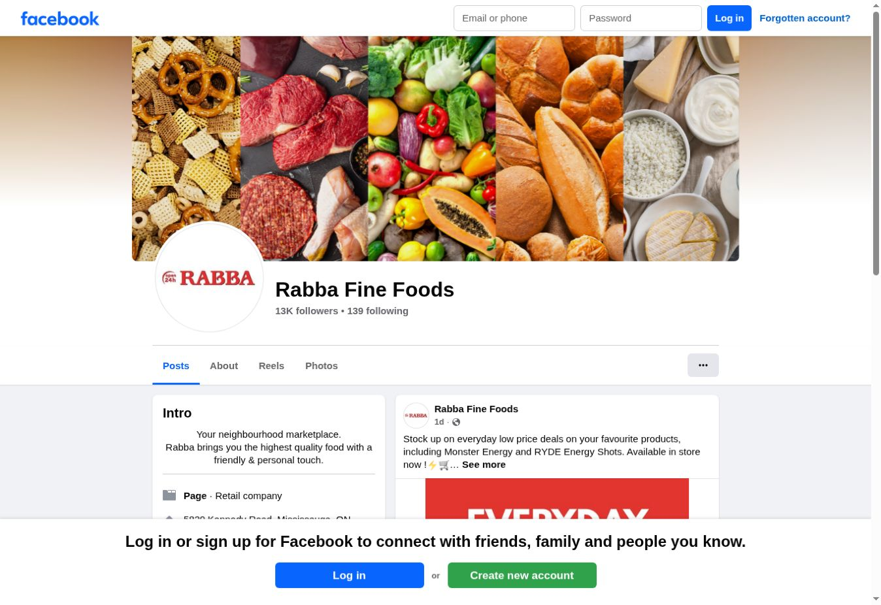
S2 Facebook profile 406337186087910; S6 direct public Facebook visit after dismissing the login overlay. Socialinsider permalinks use a different numeric page prefix; captions were cross-checked where visible, but permalink identity should be checked before client reuse.

LinkedIn and X audit

LinkedIn
Socialinsider returns 2,455 followers on 28 October and no posts for 16–28 October. Direct inspection reaches LinkedIn’s sign-in wall. Search-indexed first-party posts show that Rabba has published about community service recognition, Rabba Roots, leadership and supplier partnerships. Those examples establish available themes, not current-period performance.
The corporate story is stronger when it connects an activity to an outcome. Publish a community partnership update with verified figures, a partner’s role and a named programme. Add store-team stories and practical hiring or supplier updates. Use leadership commentary when it contributes an informed view on grocery convenience or neighbourhood needs.
Start with a proposed test cadence of one or two substantive posts a week. Measure engagement and qualified website visits before increasing output. Do not promise an engagement uplift from this cadence. Obtain authorised LinkedIn analytics before reporting impressions, clicks, audience job functions or demographic fit.

X
The live profile shows 648 followers and 7,162 lifetime posts. Its bio names the Greater Toronto Area and the family-owned, 24/7 proposition. Socialinsider returns no posts in the selected window. The visible logged-out timeline begins with a 27 February 2025 post; this is the latest post displayed in that view, not proof of the true last publication date.
X should have a defined service or public-relations role before it receives substantial production time. Keep the bio and website destination accurate, clarify where customers can get help, and monitor mentions if the team intends to support customers there. If no response process exists, set expectations and direct people to the active customer-care route.
Channel | Useful role to test | Primary measurement
LinkedIn | Community impact, people and business partnerships | Qualified visits, partner responses, relevant engagement
X | Timely updates and customer routing | Response handling and referral visits
Both | Consistent brand information | Correct links, contact route and ownership

Priority relative to other channels
Give Facebook and Instagram the regular grocery storytelling effort, while using LinkedIn for the business audience. Keep X maintained and purposeful. This allocation is a recommendation based on the observed content and available activity, not a verified revenue comparison between channels.
S2 LinkedIn 15256328 and X 889683092; S7 LinkedIn authwall and indexed first-party posts; S8 live X profile on 29 Oct. Indexed LinkedIn follower counts are older and excluded.

YouTube audit
Verified current public metric | Value
Subscribers | 18
Public videos | 24
Lifetime channel views | 4,374
Latest returned upload | 16 March 2026
Uploads returned in audit window | 0
vidIQ’s channel identity matches the supplied handle and Socialinsider channel ID. The live channel also shows 18 subscribers and 24 videos. Its Videos tab displays “Rabba Roots 2026 | Social Impact” first, with 19 views, matching vidIQ. vidIQ returned no Shorts in the Shorts list. Historical growth was unavailable, so no subscriber or view-growth claim is made.

What the library is doing today
The returned library centres on charity golf, community events, sustainability and corporate impact. These are useful trust assets, but the recent titles provide few answers to everyday shopping or meal questions. The newest returned video is more than seven months old. The homepage initially displays no content while the Videos tab lists uploads, suggesting the channel homepage needs review and a clear featured section.
Example upload | Published | Current views
Rabba Roots 2026 | Social Impact | 16 Mar 2026 | 19
Rabba Charity Golf Classic 2025 | 19 Sep 2025 | 145
Rabba Fine Foods Re-Opening in Etobicoke | 11 Oct 2018 | 1,272
These are lifetime views of videos with very different ages. The older reopening video is not a fair performance benchmark for a recent upload. Public data cannot diagnose click-through rate, retention, watch time or impressions; those require channel-owner analytics.

Recommended pilot
Create a small series of practical grocery videos: a neighbourhood store tour, a quick Rabba Kitchen meal and a recipe using a short ingredient list. Reuse suitable vertical footage across Shorts and Reels, while adapting the opening and caption to each platform. Give each video one clear destination: a recipe, relevant service page or store finder.
Organise playlists around Rabba Kitchen, Store Visits and Rabba Roots, and add a featured video to the Home tab. Compare videos after the same number of days live. Use retention and click-through data only if authorised channel analytics become available.
S9 vidIQ public channel_stats and channel_videos long/short, retrieved 29 Oct. Public counts are current snapshots, not the 13-day totals. S10 live YouTube Home and Videos tabs.

SEO baseline and crawl findings
Ubersuggest measure | Returned value | Interpretation
Site health | 76 / 100 | Tool score; not a Google ranking score
URLs crawled | 357 | 319 successful, 24 redirected, 13 broken, 1 blocked
Issue occurrences | 489 | 91 errors and 398 warnings; URLs can overlap
Organic traffic estimate | 4,077 / month | Latest month September 2026; Canada
Ranking organic keywords | 496 | Latest month; whole-location domain total
Domain authority | 42 / 100 | Ubersuggest metric, not a Google metric
Backlinks and referring domains | 13,230 and 571 | Counts do not establish link quality
The crawl completed on 29 October 2026 at approximately 16:14 UTC. Domain analysis used Canada location ID 2124 resolved through Ubersuggest. Traffic estimates are modelled visits, not GA4 sessions. No Search Console or GA4 data was used.
Issue | Affected URLs | Fix priority
4xx responses | 13 | Immediate
Blocked URL | 1 | Review intent first
Pages with broken link anchors | 6 | Immediate
Missing H1 | 170 | High template fix
Low word count | 58 | Review usefulness
Duplicate meta descriptions | 25 | High on important pages
Duplicate titles | 7 | High
Missing descriptions | 10 | Medium
Long titles | 101 | Review readability
Short titles | 58 | Review specificity
Unfriendly URLs | 23 | Avoid unnecessary URL changes
URL length warnings | 17 | Lower priority

Important data quality exception
The top-pages endpoint returns an estimated 8,963 visits for /kitchen/, exceeding the domain endpoint’s latest-month total of 4,077. The endpoints do not reconcile and may reflect different reporting snapshots or model coverage. Page estimates are therefore excluded from traffic share calculations and not added together. Confirm real landing-page demand in Search Console and GA4 before allocating budget by page traffic.
The domain history rises from 3,529 estimated visits in August to 4,077 in September 2026, about 15.5%. This is a two-month modelled comparison, not proof of a business growth trend. Large discontinuities in older history should not be assigned a cause without first-party evidence.
S1 completed Ubersuggest crawl; S11 domain_overview Canada/en; S12 backlinks_overview and domain_top_pages. Raw endpoints are retained for reconciliation.

Broken links and index controls

Repair paths customers can still reach
The crawl finds 13 URLs returning 404. Several are old recipe paths without /kitchen/. Update links at their source, and redirect an old URL only when there is a genuinely equivalent live destination. A blanket redirect to the homepage would conceal broken navigation without helping the visitor.
Example affected URL or source | Evidence and action
/household-pets-amp-general-merchandise/ | 404 in crawl; linked from homepage category area. Restore or correct this prominent route
/classic-easter-hot-cross-buns/ | 404; Easter blog links here. Check the live /kitchen/ version as the equivalent destination
/cream-cheese-banana-bread/ | 404; budget blog links here. Check /kitchen/cream-cheese-banana-bread/
/features and /features/ | Both 404; older posts still refer visitors here. Replace links with the relevant current offer page
/newsroom/rabba-fine-foods-uber-eats/ | Contains malformed relative links ending /www.rabba.com and /www.uber.com; correct to intended absolute URLs
The six source pages with broken link anchors include the Easter article, holiday budget article, summer healthy-eating article, flavour-on-a-budget article, in-store features news article and Uber Eats news article. The evidence package includes all returned source and target pairs.

Blocked recipes URL needs interpretation
Ubersuggest flags https://rabba.com/recipes without a trailing slash as blocked by an attribute. The slash version is accessible and contains recipe content. Do not remove a noindex directive automatically. First check the final response, redirect, canonical and robots directives of both variants and decide which version should be indexed. Ensure internal links point to that canonical route.

What is already present
The fetched homepage has a self-referencing HTTPS canonical and an index/follow robots directive. Ubersuggest records no missing sitemap or SSL-certificate issue. These checks do not certify every page’s indexability or every redirect. The HTTP URLs in keyword results may be stored representations; they are not proof that HTTPS redirects are currently broken.

Acceptance criteria
Retest every affected source and destination after changes. Current navigation should lead directly to a relevant successful page. Retired pages should return an intentional status, equivalent replacements should redirect once, and the canonical recipe hub should be consistently linked and indexable if intended for search.
S1 site_audit_results issue IDs response_code_4xx, have_broken_links_anchor and page_allowed; S4 live homepage navigation; S13 homepage HTML canonical and robots snapshot. Full affected URL list is included as CSV.

Page templates and content relevance

Fix the H1 pattern centrally
Ubersuggest flags 170 URLs without H1 headings, including the homepage, many recipe pages and several category pages. A direct HTML check confirms that the homepage contains no H1. It uses other heading levels for the hero and product sections. Add one clear page-level heading that describes each page’s main purpose, then keep the remaining hierarchy logical. Do not add headings solely to repeat keywords.

Metadata needs more than a character-count edit
Twenty-five URLs share descriptions and seven share titles. /community-catchup/, /locations-tims/ and /locations/ reuse the same location-finder title, although their intended purposes differ. Recipe descriptions include generic snippets such as “Ingredients:” and “Makes 4 Servings.” These provide little reason to choose a particular result.
Page | Proposed title direction | Proposed description direction
/locations/ | Find a Rabba Grocery Store in Toronto and the GTA | Explain store search, locations and service filters
/locations-tims/ | Tim Hortons Inside Rabba Locations | Identify participating locations and confirm counter hours
/community-catchup/ | Rabba Community News and Local Updates | Describe the actual content on this page
/kitchen/cream-cheese-banana-bread/ | Cream Cheese Banana Bread Recipe | Summarise the dish and useful recipe details
These are editorial directions, not tested replacements. Validate actual page content before publishing. Long and short title flags are review prompts; Google does not impose a fixed character limit for title elements. Prioritise clarity, specificity and important information near the start.

Low word count is a triage signal
Fifty-eight URLs are flagged, including /locations/ at 57 words and /kitchen/ at 25 words in the crawl extraction. The locator actually loads a map and store entries after interaction. Its low extracted word count must not be described as an empty or useless page. For recipes, add missing preparation details, timings, substitutions and serving information when these help the cook; avoid padding to an arbitrary word target.

Resolve overlapping page purposes
/beverages/ and /features-category/beverages/ share a title. A Tim Hortons story appears under both /blog/ and /newsroom/. Compare the actual content and canonical signals before choosing whether to differentiate, consolidate or redirect. Duplicate titles alone do not prove that both pages contain the same content.
The live homepage still labels a recipe section “Our Favourite Spring Recipes & Meals” in late October. Refresh seasonal merchandising and keep the prominent recipe consistent with the current campaign. The footer’s X destination is labelled Facebook in the accessibility tree; correct the label to match the destination.
S1 issue drilldowns absent_h1_tags, duplicate_meta_descriptions, have_title_duplicates and content_count_words; S4 live homepage; S13 HTML; Google Search Central title-link documentation.

Local search and structured data

Opening hours are inconsistent
The homepage’s JSON-LD entity is typed as both GroceryStore and Organization, with openingHours set to ["Tu,We,Th,Fr,Sa,Su 09:00-17:00"]. The visible header says Open 24/7. This is a factual mismatch in the published signals, regardless of whether Google currently uses the markup.
Confirm the intended entity first. If this is a corporate office schedule, label the corporate organisation separately and do not apply those hours to a generic grocery store entity. Individual branch pages should describe their own verified address, phone number and opening hours. Restaurant-counter and alcohol-sales hours should remain distinct from store hours.
The fetched GroceryStore/Organization node has no address or telephone property. That node is not sufficient branch-level local-business markup. The same graph also marks the homepage as an Article, contains a description starting “WeRabba”, and offers no sameAs profile links in the fetched organisation node. Review the SEO plugin’s entity settings and use markup that matches the page’s real purpose. Absence on this homepage does not establish absence across the entire site.

The locator works but needs a crawlable companion
A manual Toronto search loads the map and a table showing 38 entries. Store categories include Tim Hortons, Subway, AH-SO Sushi, Paramount and Rabba Kitchen. The initial text extraction did not expose the populated table, showing why a static crawl alone is insufficient to judge this feature.
The first displayed rows include several entries without a visible Directions link. The 2125 Lakeshore Blvd. W row’s Directions link points to a Google review URL ending /review. Audit these destinations so every branch provides a clear route to navigation, and distinguish a review request from a directions action.
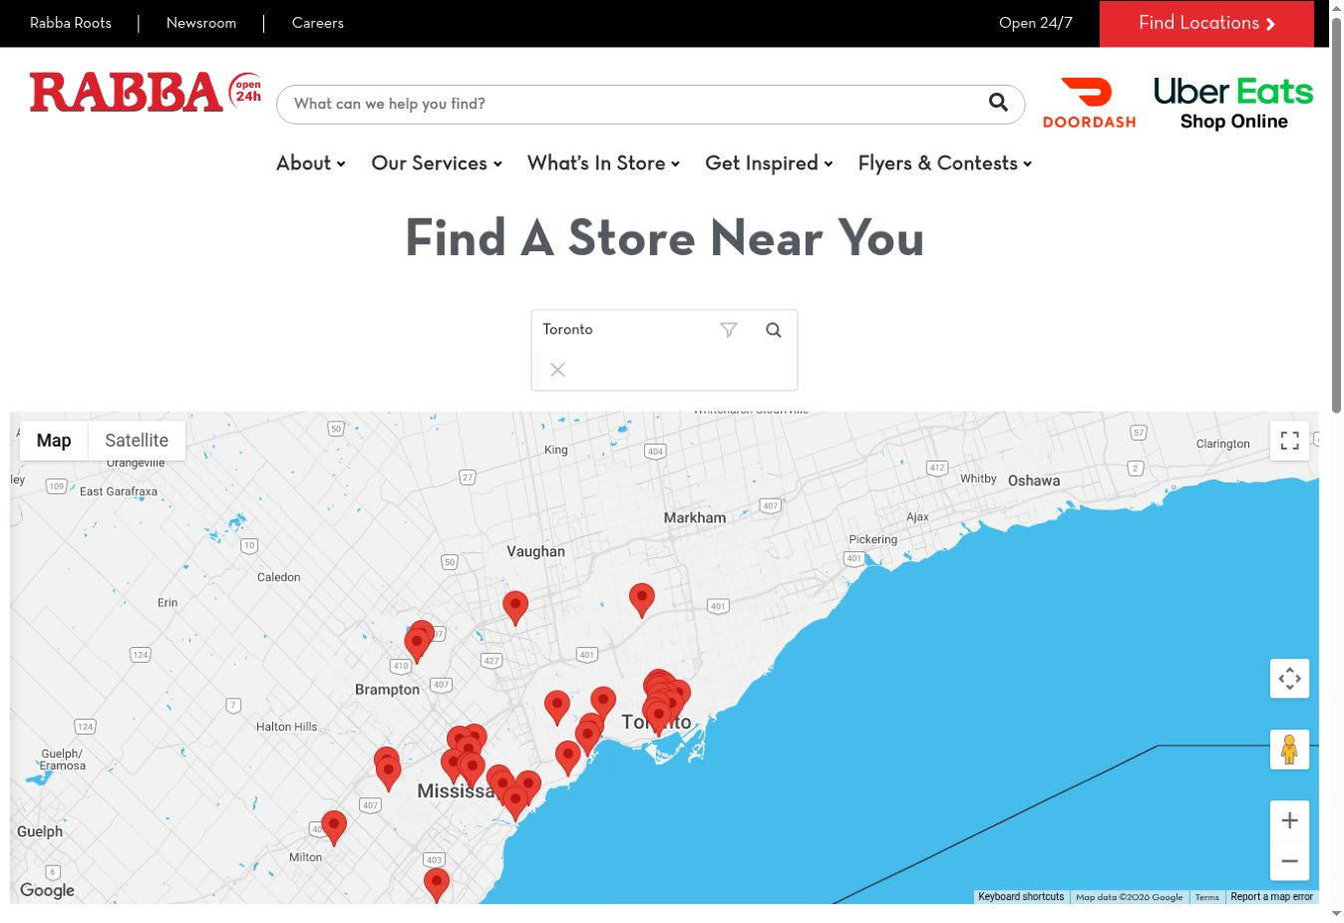
Build or strengthen a stable page for each verified active store, linked from the locator. Include accurate services, directions, transit or parking context where useful, accessible phone links and current hours. Reconcile the 38 displayed entries with the operational store list before calling this the number of open stores. Google Business Profile accuracy, review response and map-pack positions were not audited from an authorised account.
S13 fetched homepage HTML and JSON-LD; S4 live locator test on 29 Oct. Technical reference: Google Search Central LocalBusiness structured-data documentation. Screenshot records the locator state, not proof of operational status.

Performance and search opportunities
Metric | Supplied mobile audit | Assessment
Load time | 1.56 s | GREAT
Interactivity | 82.00 ms | GREAT
Visual stability | 0.00 | GREAT
The supplied Rabba audit screenshot rates mobile load time 1.56 seconds, interactivity 82.00 milliseconds and visual stability 0.00 as GREAT. These are the primary performance results for this corrected presentation report. The screenshot does not show its capture date or underlying test scope. Its labels are reproduced without assuming a different metric definition.
An earlier Ubersuggest API response separately returned mobile lab LCP 38.1 seconds, desktop lab LCP 3.8 seconds and desktop lab CLS 0.213, while mobile field categories were FAST. These are not interchangeable with the supplied screenshot. Keep the earlier result as a discrepancy to reconcile, not evidence that typical mobile users experience a slow site. The earlier 247 KB unused JavaScript and estimated savings are diagnostic leads, not confirmed urgent fixes. Preserve the supplied GREAT mobile experience and prioritise verified link, template and local-information issues.

Prioritise local intent over broad traffic
Canada keyword | Monthly volume | Returned position | Mapped page
24 hour grocery toronto | 260 | 5 | Homepage
rabba mississauga | 170 | 4 | Homepage
rabba near me open now | 90 | 5 | Kitchen archive
rabba hours | 90 | 2 | Kitchen archive
rabba kitchen by paramount | 590 | 3 | Kitchen archive
rabba flyer | 210 | 1 | Every Day Low Prices archive
These are Ubersuggest’s returned keyword estimates and positions, with individual record updates spanning late August to October 2026. They are not live checks of every Toronto neighbourhood or map-pack rank. Several local queries map to the kitchen archive or homepage rather than a precise store/service page, suggesting an opportunity to improve destination relevance and internal links.
Give store-hours searches a verified location answer and make the flyer route visibly current. Keep recipe discovery useful, but link ingredients and meal inspiration to relevant store or service pages. Do not chase unrelated competitor-brand terms simply because the domain ranks for them. Track calls, directions clicks, flyer visits and delivery handoffs with clearly named events; revenue attribution requires separate evidence.
Primary performance source: supplied Rabba mobile audit screenshot image(2).png. Earlier Ubersuggest PageSpeed response retained separately in the evidence. S11 supplies keyword data. Reference thresholds: web.dev Web Vitals; screenshot labels and scope are not silently redefined.

Prioritised action plan
When | Action and owner | Completion evidence
Days 1–7 | Web developer and operations: correct entity hours; verify branch information | Visible content and schema agree; branch facts approved
Days 1–7 | Web developer: fix homepage category route and malformed links | Relevant successful destinations; affected sources retested
Days 1–14 | SEO and developer: repair H1 templates and priority metadata | Representative pages checked, then affected templates recrawled
Days 1–14 | Analyst and developer: reconcile performance sources | Supplied GREAT mobile results distinguished from the earlier lab diagnostic
Days 8–30 | Local SEO and operations: improve location pages and directions links | Verified services, hours, phone and navigation for each pilot branch
Days 8–30 | Social team: test location-led food and convenience content | Consistent tagged destinations and recorded creative hypotheses
Days 15–45 | SEO editor: consolidate or differentiate overlapping archives | Approved canonical plan, internal links and redirects where needed
Days 31–60 | Video team: launch a small practical food/store series | Clear channel homepage, playlists and same-age video comparison
Days 31–90 | Analyst: review results against a stable baseline | First-party search and conversion reporting, consistent social definitions

How to evaluate progress
Technical checks should count resolved affected URLs and successful customer journeys. Search reporting should separate branded and non-branded queries, compare the same date lengths, and examine location and service landing pages. Social reporting should include every post, including zero-engagement posts, and distinguish public engagement from owned reach and impressions.
For a proposed four-week content pilot, test two practical food or store videos and one useful offer or community post per week on Instagram and Facebook, adapted to each platform. Publish one or two relevant LinkedIn updates weekly. This is a test plan, not an industry benchmark or guaranteed publishing requirement. Set commercial targets after first-party baseline collection rather than inventing a percentage uplift.

Authority and partnerships
Ubersuggest returns 10,766 follow links and 2,464 nofollow links across 571 referring domains. The homepage has 471 referring domains in the top-pages endpoint, suggesting that much of the reported link authority concentrates there. No link-quality sample was reviewed, so there is no basis for a toxicity claim or disavow recommendation. Relevant community and supplier stories can naturally link to the corresponding programme or location page when editorially appropriate.
Recommendations draw on S1–S13. Dates above are proposed implementation windows from project start, not booked commitments. No accounts or website settings were changed during this audit.

Sources and verification notes
Original research was collected on 29 October 2026. This corrected report also incorporates the subsequently supplied Rabba mobile audit screenshot as the primary performance reference. The evidence package preserves the original connector responses and documents why the separate lab result is not used as a headline weakness.
Source | Coverage and exact route
S1 | Ubersuggest site_audit rabba.com; completed crawl and six issue drilldowns plus broken-link sources
S2 | Socialinsider project Rabba Fine Foods; public LinkedIn, Facebook, Instagram, X and YouTube profiles; summaries, daily data and top posts
S3 | Ubersuggest pagespeed_audit rabba.com, mobile and desktop
S4 | Direct browser review https://rabba.com/ and https://rabba.com/locations/
S5 | https://www.instagram.com/rabbafinefoods_/ and /p/DfAqx9cF_-w/
S6 | https://www.facebook.com/RabbaFineFoods/
S7 | https://www.linkedin.com/company/rabba-fine-foods/ and indexed first-party post examples
S8 | https://x.com/RabbaFineFoods
S9 | vidIQ public channel UCEC9fSFEDEYFvQFW7UB7Gzw; current stats, long uploads and Shorts list
S10 | https://www.youtube.com/@rabbafinefoods3034 and its Videos tab
S11 | Ubersuggest domain_overview rabba.com, English, Canada 2124
S12 | Ubersuggest backlinks_overview and domain_top_pages rabba.com
S13 | Fetched https://rabba.com/ HTML, canonical, robots, headings and JSON-LD

Access limits that affect interpretation
Sociality.io returned no Rabba accounts or tracked competitors. No Sociality analytics were used. The LinkedIn plugin supports people search rather than company analytics; Socialinsider and indexed first-party company posts were used instead. LinkedIn’s direct profile view required sign-in. Instagram restricted the alcohol post for logged-out access. No credentials, new tracking profiles or account permissions were added.
Socialinsider’s rolling history limit prevents a reliable 90-day trend report in this session. Public profile data cannot establish ad spend, sales, audience quality, Story completion, private messages or customer-service response speed. Reach and impression fields are withheld where ownership and consistency could not be verified. Zero uploads in the window do not mean zero views of older YouTube content.

Technical reference links
https://developers.google.com/search/docs/appearance/structured-data/local-business
https://developers.google.com/search/docs/appearance/title-link
https://web.dev/articles/vitals
LinkedIn theme example: https://www.linkedin.com/posts/rabba-fine-foods_we-are-honoured-to-share-that-rabba-fine-activity-7496580916345991168-2R8i

